Texas State University is a tobacco-free campus.
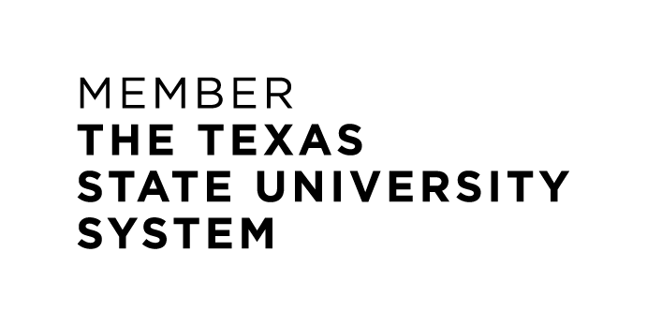

presents

Mixture of Emotions
Kevin Arratia-Diaz, Tenor
Junior Voice Recital
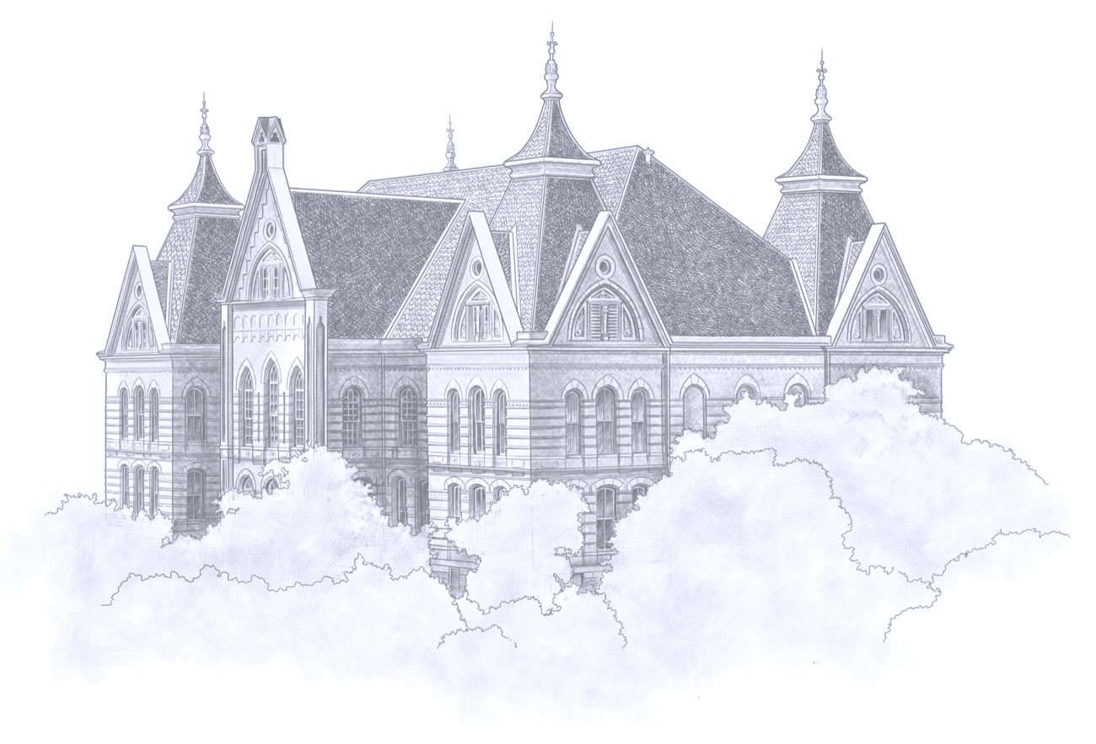

In collaboration with
Michael Brady, Piano

THURSDAY|APRIL 15, 2021 6 PM|RECITAL HALL
SAN MARCOS, TX PERFORMING ARTS CENTER

Program

“Villanelle” Hector Berlioz
from Les nuit d’été (1809-1869)

Die Nacht Richard Strauss
Ruhe, Meine Seele! (1864-1949)

“Vainement, ma bien-aimée” Édouard Lalo
from Le Roi D’ys (1823-1892)

Intermission

“Maria” Leonard Bernstein
from West Side Story (1918-1990)
Stephen Sondheim
(1930- )

La Partida Fermin Maria Alvarez
(1833-1898)

“Love Sounds the Alarm” G. F. Handel
from Acis and Galatea (1685-1759)

This recital is presented in partial fulfillment of
requirements for the Bachelor of Music in Vocal Performance.

